**APPENDIX 1**

BLOOD DONATION

END TERM REPORT

*by*

Section: K19ZV

Roll Numbers: 1, 8, 13



**Department of Intelligence Systems**

**School of Computer Science Engineering**

**Lovely Professional University, Jalandhar**

**April-2020**

**APPENDIX 2**

**Student Declaration**

This is to declare that this report has been written by us. No part of the report is copied from other sources. All information included from other sources have been duly acknowledged. We aver that if any part of the report is found to be copied. We shall take full responsibility for it.



(Signature)

Name- SALONI

Roll No. - 13

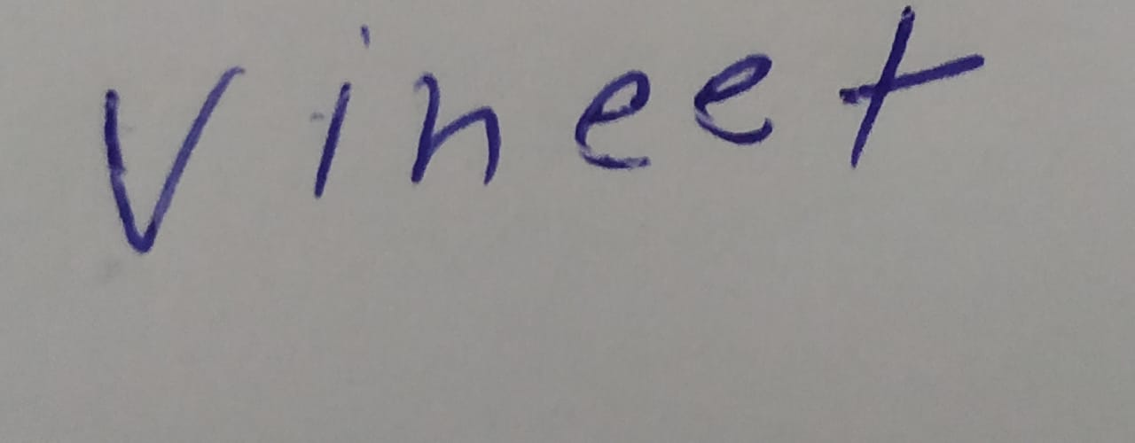

Name-Vineet Kumar Shukla

Roll No. -8



Place- LPU Name- SUREN RANA

Date- 10-4-2020 Roll No. - 1

**APPENDIX 3**

**TABLE OF CONTENTS**

**TITLE PAGE NO.**

1. **Background project …………. …………………………………… 6**

**1.1 Objectives…………………………………………………………….... 7**

1. **Description of project………………………………………...…….. 8**

**2.1 Pictorial chart of project…………………………………………….... 9**

**3. Work division in terms of role among students………………….. 9**

**4. Implementation of scheduled work of project………………….. 11**

**4.1 Sign up/Login page…………………………………………… 11**

**4.2 Home page…………………………………………………….. 12**

**4.3 Search for blood……………………………………………… 13**

**4.4 Refer a friend………………………………………………… 14**

**4.5 Contact us……………………………………………………. 15**

**4.6 About Us……………………………………………………… 16**

**APPENDIX 4**

BONAFIDE CERTIFICATE

Certified that this project report “BLOOD DONATION” is the bonafide work of “Saloni, Suren Rana, Vineet Kumar Shukla” who carried out the project work under my supervision.

**<<Signature of Supervisor>>**

Name of supervisor**-** Ashish Shrivastava

Academic Designation-

ID of Supervisor-

Department of Supervisor-

**BACKGROUND OF PROJECT**

Blood Donation project describes the smart blood bank management system. The purpose of this project was to develop a blood management information system to find the nearest blood donation place as well as nearest blood bank .and to assist in the management of blood donor records and ease or control the distribution of blood in various part of country on the basis of hospitals demand. People will get to know about the blood donation drives going around them. This site will also allow to clear any kind of queries regarding donation, or any post donation concerns, etc. Also it will help u referring a friend in need of blood.

**MOTIVATION**

Blood Donation is a web based project. Today you can easily connect with anything through internet services. So online platform is the best choice for our project. This project aims serving for human welfare. It has all the information anyone can need. The persons who need blood donor, they can search and find blood donors by using our website.

**OUTCOME OF PROJECT**

This website is mainly for the people needing blood or willing to donate blood.

Description - The home page offers several options, for registering as a donor or to search blood etc.

Check availability – Availabilty of blood in the blood banks can be checked.

Nearby Blood Bank – Nearest blood bank can be viewed.

**OBJECTIVES OF PROJECT**

* The project is mainly towards person who are willing to donate blood to the patients. Through this system it will be easier to find a donor for exact blood type and easy to build connection between donor & the blood bank authorities.
* The main intend of building this website is to form the procedure of blood donation & motivate donors in order to donate blood.
* It aims at maintaining all the information pertaining to blood donors, different blood groups available nearby and help people manage in a better way.
* It aims to provide transparency in the field, make the process of obtaing blood from a blood bank hassle free and corruption free and make the system of blood bank management effective.

**DESCRIPTION OF PROJECT**

Blood Donation site contains information about the number of blood banks and applicants willing to donate blood.

**Modules:** Project has 5 modules –

REGISTER :-

Registration page includes the information of the donor who want to register. Donor can register the by clicking account on register option at homepage. He or she can add the account for further enquiry of the blood donation.

WHY TO DONATE BLOOD :-

At home page there is a option of why to donate blood where by clicking people can get information regarding it.

WHO CAN GIVE BLOOD :-

A person who is 18 or above can donate blood. It is a good step to donate a blood. U can get more information regarding this on the website.

REFER A FRIEND :-

This page will help people gain awareness about the local blood donation drives going on around and gather more people who are willing to donate blood or help the people who are in need of blood.

CONTACT US :-

This page will help people clear any kind of queries or doubts regarding bv blood donation process, post blood donation concerns, need of blood, get any details of blood etc.,

**PICTORIAL FLOW CHART OF PROJECT**









**WORK DIVISION IN TERMS OF ROLE**

**STUDENT NAME ROLE IN PROJECT**

SALONI: She is responsible for designing webpages “to check the

Availability of blood group in nearest blood bank” ,

“Contact Us page” , “Refer a Friend page”, which will

Be very helpful in locating the donor and the acceptor.

SUREN RANA: He is responsible for desigining the “Home Page” of

The Website which includes some videos regarding

Blood Donation as well as login portal. He is also

designing “Register page”.

VINEET KUMAR He is responsible for designing “Why to donate blood

SHUKLA: page”, “Why it is important to donate blood page” ,

“Feedback page” where people can share their

personal experience

**SCHEDULED WORK OF PROJECT**

SIGN UP PAGE/ LOGIN PAGE

A person can make his or her account using this page by providing email-id and a password. If the person has already registered himself, then he can directly login by using his id and password at login portal given above.

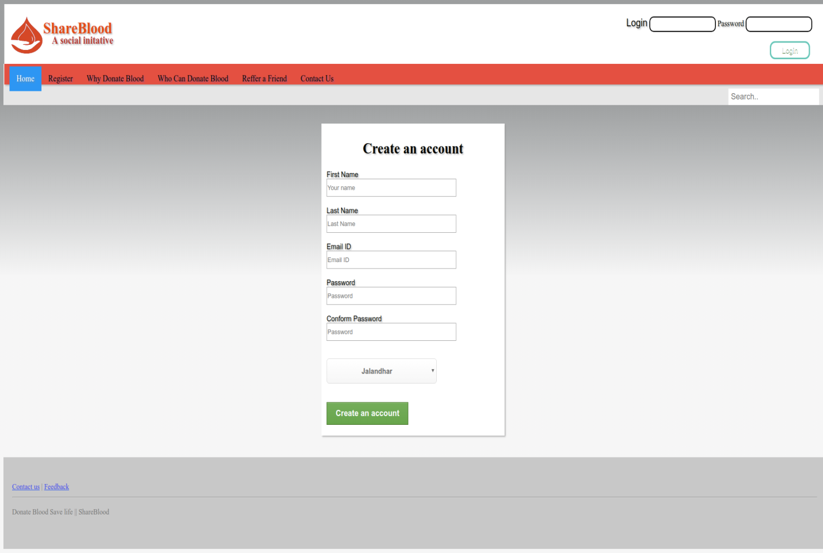

HOME PAGE

Given below is the website homepage. As the person login into his/her account, they land on this page. Here they can register themselves as donor or acceptor, refer this site to their known people, contact us about any query, find the donor according to their need, give feedback, etc.

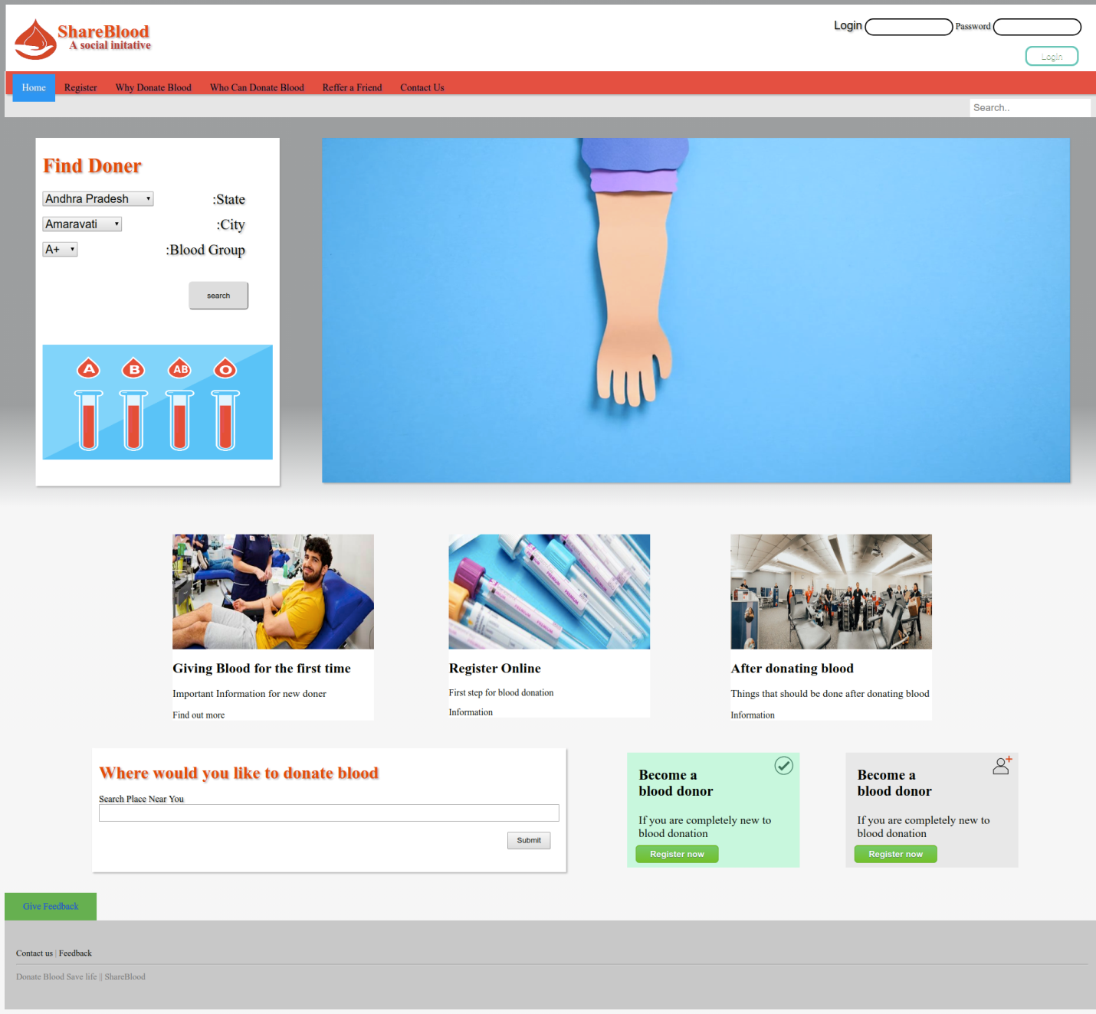

SEARCH FOR BLOOD

Here a person can serach for the blood from the blood banks near him.

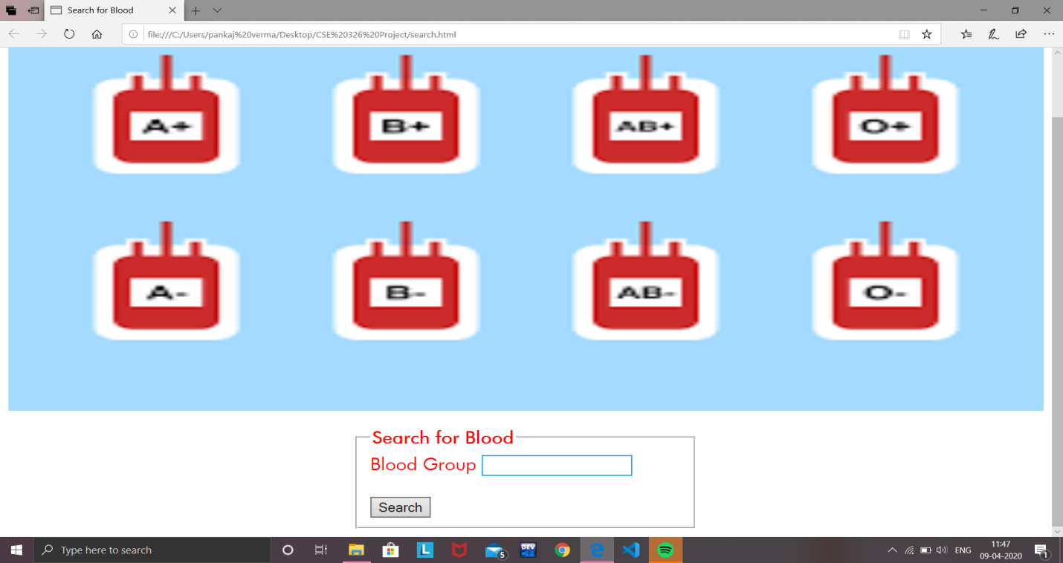

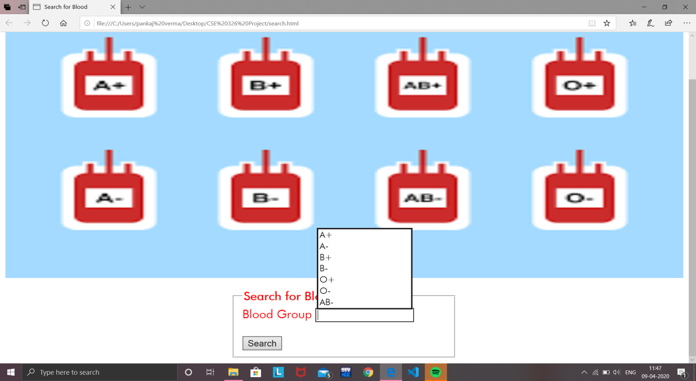

REFER A FRIEND

Here a person can refer this website to his knowns who may be in a need of blood, or to make them aware about the blood donation drives going around them so they can donate blood for good.

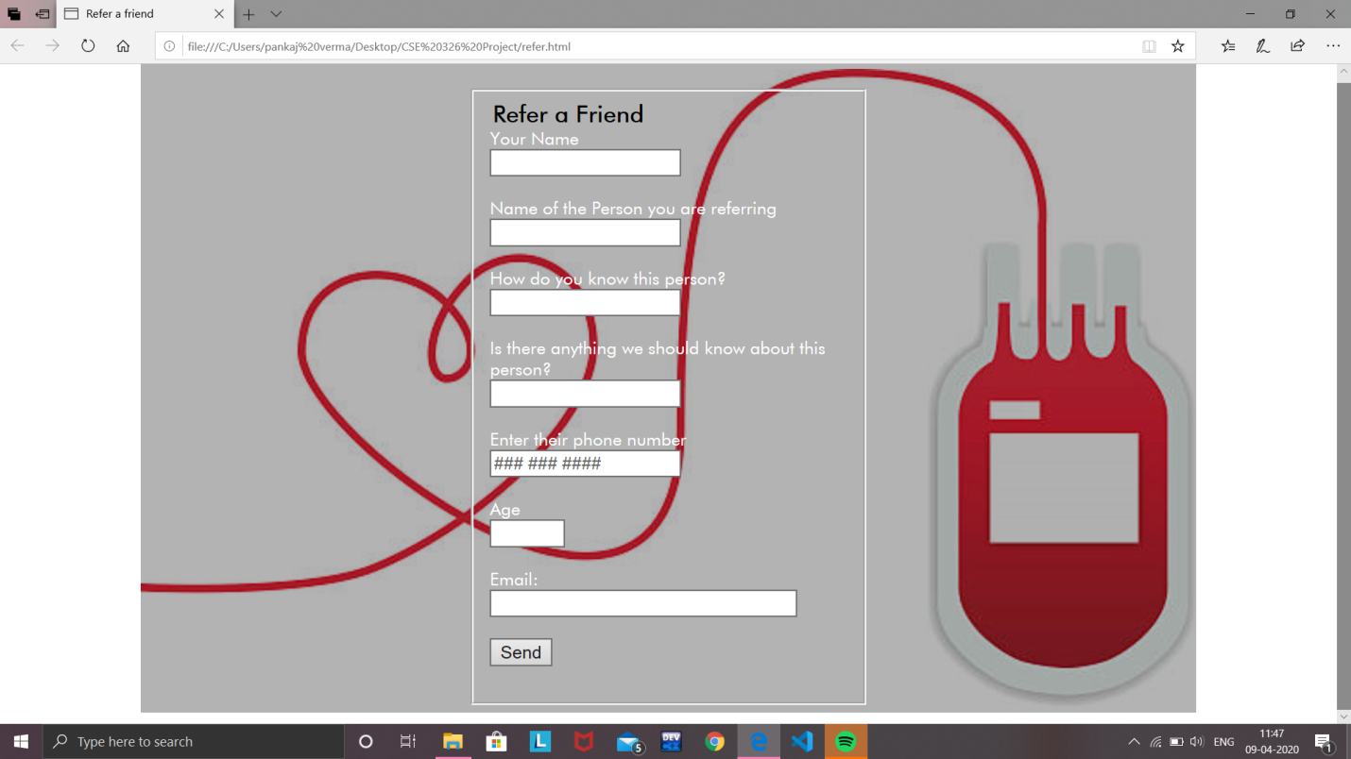

CONTACT US

Here a person can contact us either by filling this form or by calling on the number given below for clearing any kind of queries/doubts, for post donation concerns,etc.

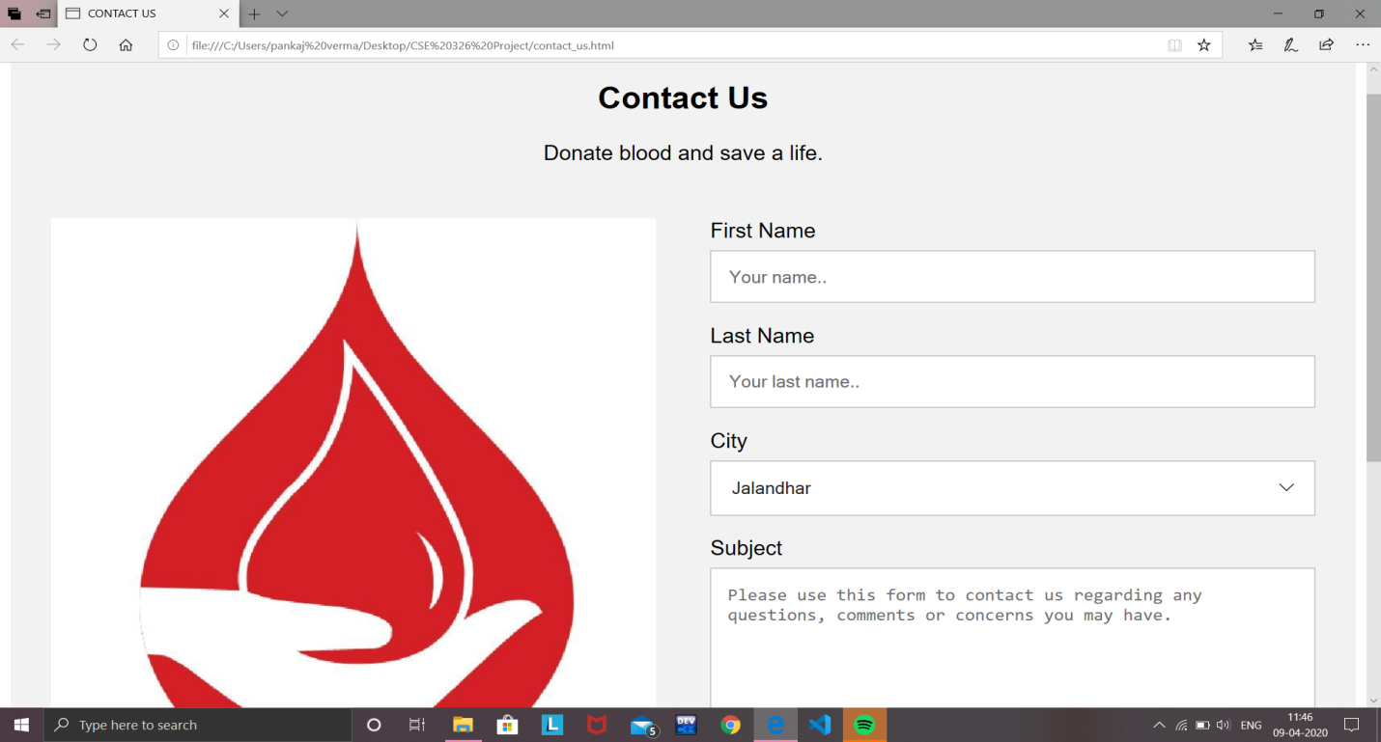

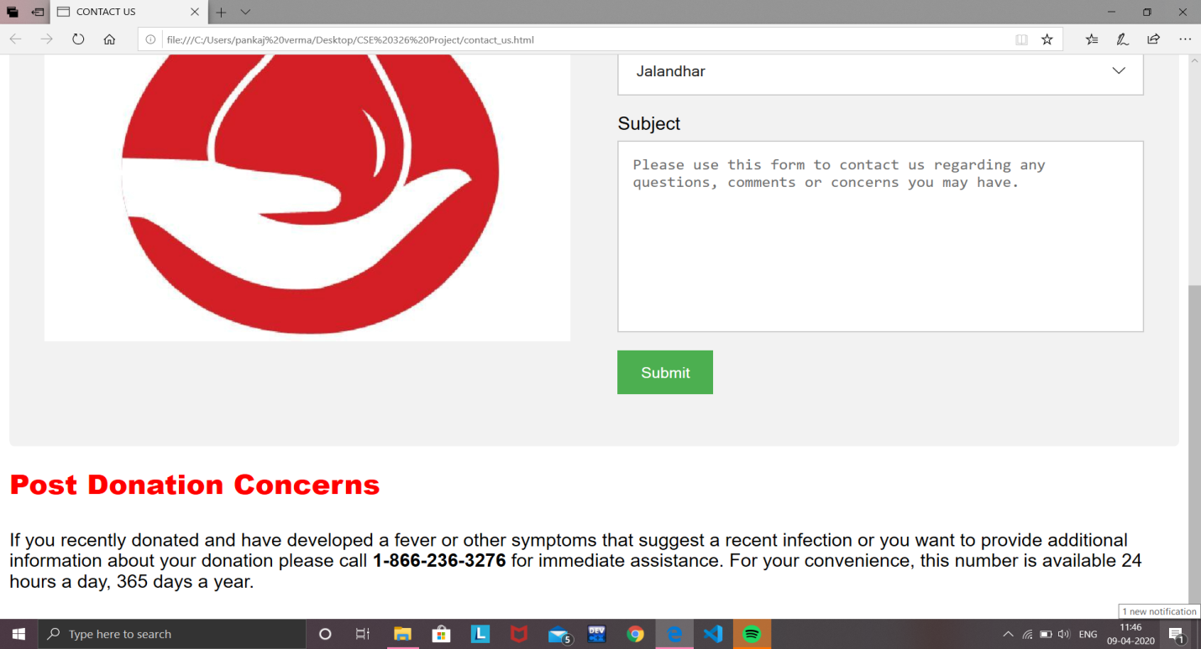

ABOUT US

Here a person can know about us. They will get every kind of information regarding this site or blood donation etc.

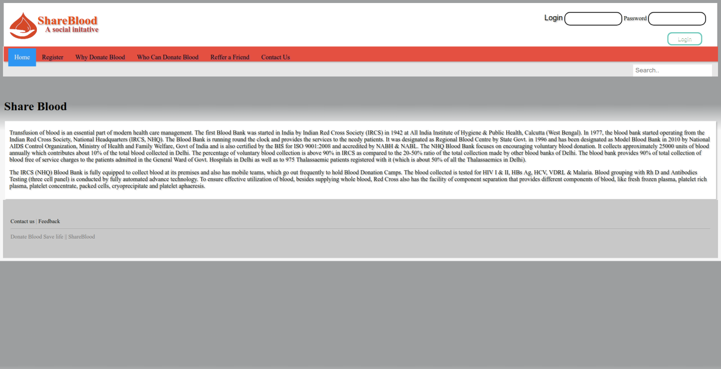

**TECHNOLOGIES USED**

HARDWARE INTERFACES

* High Processor
* High RAM

SOFTWARE INTERFACES

* Windows
* Internet Explorer, Chrome
* Notepad

**SWOT ANALYSIS ACHIEVED IN PROJECT**

STRENGTHS:

* Well developed platform
* Excellent media
* Good services
* Access to many well known blood banks

WEAKNESSES

* Facilities not under our control

OPPORTUNITIES

* More hits
* Wider use
* Introducing new services

THREATS

* Complaints
* Donor dissatisfaction
* Loss of donors
* Loss of data files